Government Polytechnic Jalgaon

PROJECT REPORT ON INTERNSHIP CARRIED OUT AT PASSION SOFTWARE SOLUTION, JALGAON



Report By: -

Snehal Ramkishan Sharma

Mentor: -

Asha Chaudhary

# 

# **MAHARASHTRA STATE BOARD OF TECHNICAL EDUCATION**

# **Certificate**

This is to certify that **Snehal Ramkishan Sharma** Roll No.**__** **Student of CO5K** of **5th** Semester of Diploma in **Computer Engineering** of **Government Polytechnic, Jalgaon** (Code:0018) has completed the **Project Report** satisfactorily in the subject **Internship (12 WEEKS) [315004]** for the Academic Year 2025-2026 as prescribed in the curriculum

Place: **Jalgaon** Enrollment no: **23640220201**

Seat no:

Subject Teacher External Examiner

Head of the Department Principal

Seal of Institution

GOVTERNMENT POLYTECHNIC JALGAON



**-SUBMISSION-**

I **Snehal Ramkishan Sharma** as student of **5th** Semester of the Programme **Computer Engineering** humbly submit that we have completed from time to time the Project work as described in this report by our own skills and study in academic year **2025 - 2026** as per instructions and guidance of **Prof. Asha Chaudhary**.

And that following students were associated with me for this work, However, quantum of my contribution has been approved by the Lecturer. And that I have not copied the report on its any appreciable part from Any other literature in contravention of the academic ethics.

Date: Signature of Student

PART-B Project Report

Internship report

1. Rationale

Internship report.

1. Aim/Benefits of the micro-project

To create the report of Internship and projects carried in it.

1. Course Outcome Addressed
2. Observe time/resource management and industrial safety aspects.
3. Acquire professional experience of industry environment.
4. Establish effective communication in working environment.
5. Prepare report of assigned activities and accomplishments.

Teachers Evaluation Sheet

**Name of Student: -** Snehal Ramkishan Sharma

**Enrolment No.: -** 23640220201

**Name of Project: -** Internship Report

**Course Title: -** Internship (12 WEEKS)

**Code: -** 315004

**Title of Micro-Project: -** Internship Report

Course Outcome Addressed

1. Observe time/resource management and industrial safety aspects.
2. Acquire professional experience of industry environment.
3. Establish effective communication in working environment.
4. Prepare report of assigned activities and accomplishments.

Evaluation as per Suggested Rubric Assessment of Micro-Project

|  |  |  |  |  |
| --- | --- | --- | --- | --- |
| Characteristics To Be Assessed | Poor | Average | Good | Excellent |
| Relevance to the Course |  |  |  |  |
| Literature Review/Information Collection |  |  |  |  |
| Analysis of Data and Representation |  |  |  |  |
| Completion of Target As per Project Proposal |  |  |  |  |
| Report Preparation |  |  |  |  |
| Presentation of the Micro Project |  |  |  |  |

Micro-Project Evaluation Sheet

|  |  |  |
| --- | --- | --- |
| Process and product Assessment | Individual Presentation/viva | Total Marks |
|  |  |  |

# Abstract

**———————————**

The **Internship course** is introduced to all diploma programs with the objective of developing the traits of **industry culture** among students before they enter into the world of industry. By exposing and interacting with the real-life industrial setting, students will appreciate and understand the actual working of an industry, as well as the **best practices adopted in industry**.

**Career paths** focus on **job role-based training** aligned to the market demand. Students can access a number of different career offerings and select the one that supports their **career goals** most effectively.

Through the **blended learning approach**, students can learn at their own pace, in a way that best suits their individual learning style. The experience also allows learners to interact with content using a **classroom-based environment**.

# Acknowledgement

**——————————————————————**

The successful completion of this project marks the beginning of an ongoing learning experience of transforming ideas and concepts into real-life practical systems.  
This project has been a valuable learning experience for me at every stage. It has also given me the confidence to work in a professional environment. I believe that the knowledge and skills gained during this project will greatly benefit my future endeavours.

First and foremost, I would like to express my sincere gratitude to **Dr. Parag Patil, Principal, Government Polytechnic, Jalgaon**, for providing me with the opportunity to carry out this project work in the institute and for his continuous support and encouragement.

I am also deeply thankful to **Dr. P. P. Chaudhari, Head of the Department of Computer Engineering**, for his valuable guidance and motivation throughout the course of this project.

With heartfelt appreciation, I extend my sincere thanks to my **mentor, Asha Chaudhary Ma’am**, for his active involvement, constant guidance, and encouragement, without which the successful completion of this project would not have been possible.

I am equally grateful to my **Class Teacher, Dr. Ashwini Lokhande Ma’am**, for her support, valuable suggestions, and encouragement during the project work.

Finally, I am highly thankful to **Mr. Manoj Kumavat Sir** at Passion Software Solution for taking a keen interest in my project, providing insightful suggestions, and helping me directly or indirectly in its successful completion.

**Certificate**

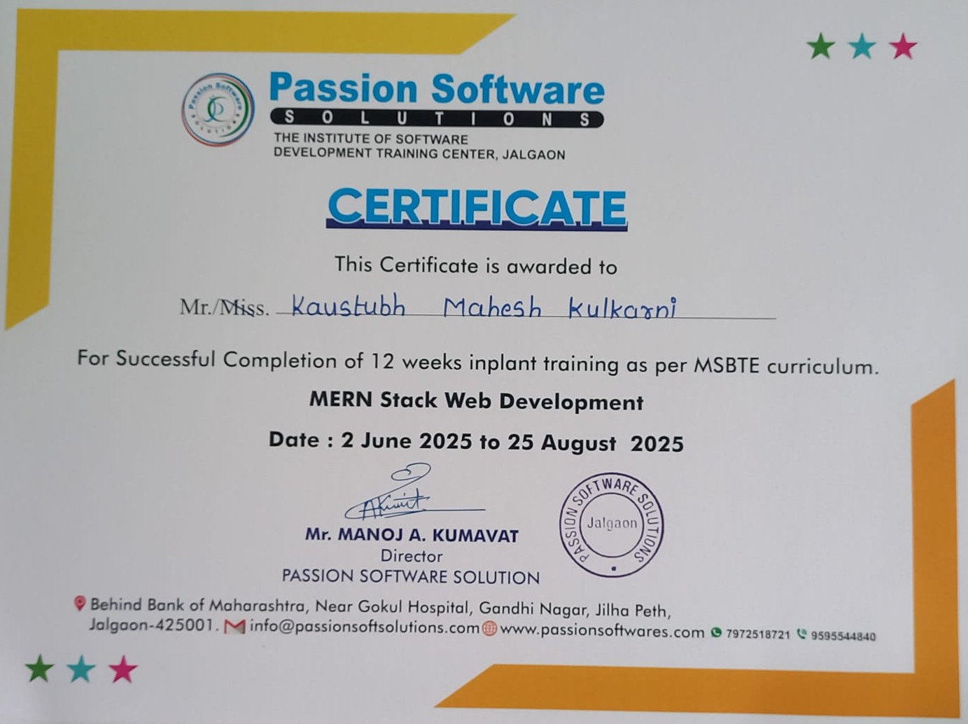

**Attendance Record**

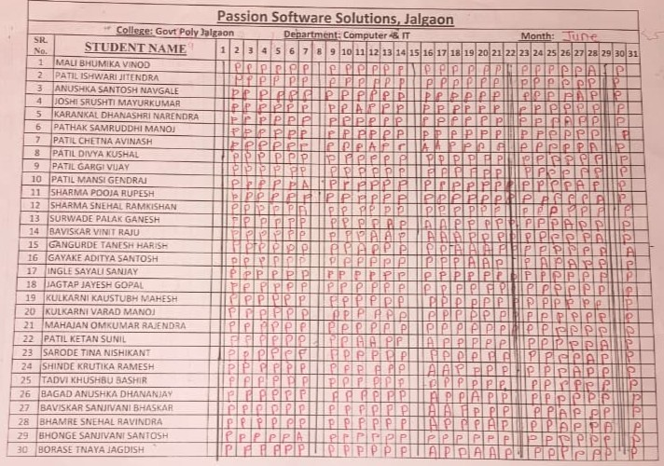

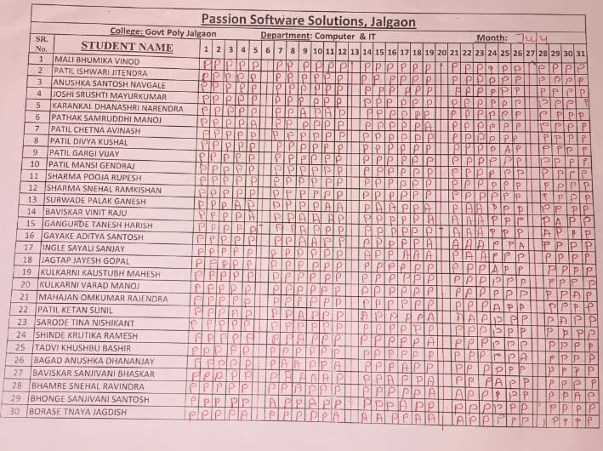

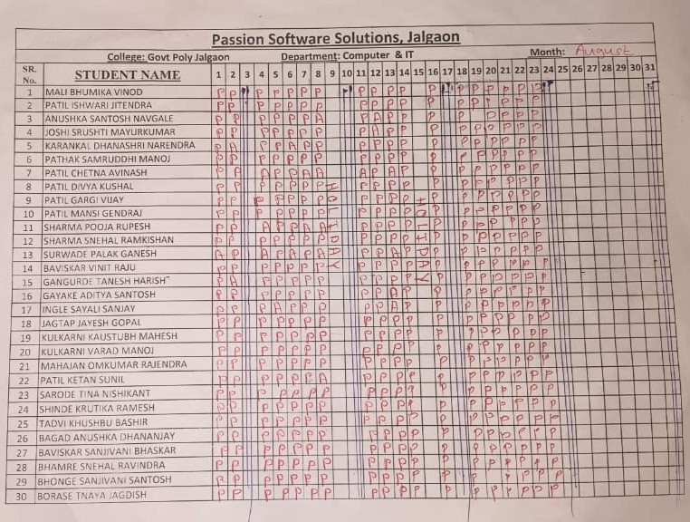

**Internship 2025**

**Weekly Dairy**

Name: Snehal Ramkishan Sharma.

Enrollment no. 23640220201

Semester: 5th

Academic Year: 2025-26

Branch: Computer Engineering

Industry name: Passion Software Solutions, Jalgaon.

Name of Faculty Mentor: Prof. Asha Chaudhary.

Name of Industry Supervisor: Manoj A Kumavat.

Designation of Supervisor: CEO & Director

**Week-1**

|  |  |  |  |
| --- | --- | --- | --- |
| **Day & Date** | **Discussion**  **Topics / Activity** | **Corrections and Remarks** | **Signature of Industry Mentor** |
| Monday, June 2 2025 | Topics Covered:  HTML: Introduction of HTML, Structure of HTML, Formatting and Heading Tags |  |  |
| Tuesday, June 3 2025 | Topics Covered:  HTML: Attributes of Body Tag, Unordered List  JavaScript: Introduction, History, Datatypes, Output Statements |  |
| Wednesday, June 4 2025 | Topics Covered:  HTML: Ordered List, Description List, Nested List, Images in HTML, Anchor Tag |  |
| Thursday, June 5 2025 | Topics Covered:  HTML: Tables, Table Attributes, Row span & Colspan  JavaScript: Variable Values Printing, Input from User, Operaators in JavaScript, Typecasting |  |
| Friday, June 6 2025 | Topics Covered:  HTML: Layouts Making Using Table  JavaScript: Programs on Assignment, Relational, Logical, Increment & Decrement Operators |  |
| Saturday, June 7 2025 | Topics Covered:  HTML: Marquee Tag  JavaScript: Program on Conditional Operator, Decision Control Structure: if statement  Saturday Activates Task: Self Introduction |  |

**Week-2**

|  |  |  |  |
| --- | --- | --- | --- |
| **Day & Date** | **Discussion**  **Topics / Activity** | **Corrections and Remarks** | **Signature of Industry Mentor** |
| Monday, June 9 2025 | Topics Covered:  HTML: Frameset, Frameset Rows and Cols  JavaScript: Decision Control Structure: If-Else, Nested If-Else |  |  |
| Tuesday, June 10 2025 | JavaScript: Ladder Else-If  Extra Practice Session |  |
| Wednesday, June 11 2025 | Topics Covered:  HTML: Form Tag, Attributes of Form Tag, Input Tag, Input Tag Type Attribute  JavaScript: Introduction to Loops, Types of Loops |  |
| Thursday, June 12 2025 | Topics Covered:  HTML: Form using Table, Audio-Video in HTML  JavaScript: While Loop, For Loop |  |
| Friday, June 13 2025 | JavaScript: Nested for Loop  Extra Practice Session |  |
| Saturday, June 14 2025 | Saturday Activates Task: PPT Presentation |  |

**Week-3**

|  |  |  |  |
| --- | --- | --- | --- |
| **Day & Date** | **Discussion**  **Topics / Activity** | **Corrections and Remarks** | **Signature of Industry Mentor** |
| Monday, June 16 2025 | Topics Covered:  CSS: Introduction to CSS, Types of CSS, Colors in CSS, Ways to Insert CSS  JavaScript: Nested for Loop, Patterns Using Loop |  |  |
| Tuesday, June 17 2025 | Topics Covered:  CSS: Backgrounds in CSS, Border Styles in CSS, Semantic Tags, Margins in CSS  JavaScript: do-while Loop, break and Continue, Switch Case |  |
| Wednesday, June 18 2025 | Topics Covered:  CSS: Padding in CSS, Login Page Designing |  |
| Thursday, June 19 2025 | Topics Covered:  CSS: Navigation Bar Designing using CSS, Links in CSS, Animation in CSS  JavaScript: Functions in JavaScript, User-defined Functions in JavaScript |  |
| Friday, June 20 2025 | Topics Covered:  CSS: Program on Animation, Animation Direction, Transitions in CSS  JavaScript: Array in JavaScript, Calling User-Defined Function from JavaScript (Other File) |  |
| Saturday, June 21 2025 | Extra Practice Session  Saturday Activates Task: Aptitude Test |  |

**Week-4**

|  |  |  |  |
| --- | --- | --- | --- |
| **Day & Date** | **Discussion**  **Topics / Activity** | **Corrections and Remarks** | **Signature of Industry Mentor** |
| Monday, June 23 2025 | Topics Covered:  CSS: CSS Text properties, Alignment, Direction, Transformation, Text Shadow, Font style  JavaScript: JavaScript Array Methods & Properties, Array Destructuring, Array Map, Array Filter, Array Reduce |  |  |
| Tuesday, June 24 2025 | Topics Covered:  CSS: Cursors in CSS, Text-Shadow & Box-Shadow  JavaScript: Functions Types in JavaScript (Anonymous Functions, Arrow Functions, Callback Function) |  |
| Wednesday, June 25 2025 | Topics Covered:  CSS: Positions in CSS, Z-index, Display Properties  JavaScript: Object Properties and Methods |  |
| Thursday, June 26 2025 | Topics Covered:  CSS: Grids in CSS, Gap between Tiles  JavaScript: Event Handling, Types of Events in JavaScript(OnClick, OnLoad, OnSubmit, OnMouseover) |  |
| Friday, June 27 2025 | Topics Covered:  CSS: Grid Lines in CSS  JavaScript: OnChange Event, getElementById() Function |  |
| Saturday, June 28 2025 | Extra Practice Session  Saturday Activates Task: Webpage Designing |  |

**Week-5**

|  |  |  |  |
| --- | --- | --- | --- |
| **Day & Date** | **Discussion**  **Topics / Activity** | **Corrections and Remarks** | **Signature of Industry Mentor** |
| Monday, June 30 2025 | Topics Covered:  CSS: Justify Content Property, Align Content Property,  JavaScript: JavaScript Object Methods, JavaScript Object Constructor |  |  |
| Tuesday, July 01 2025 | Topics Covered:  CSS: Media Quires in CSS, Breakpoints in Media Quires, CSS Media Types, CSS Common Media Features, Syntax of Media Quires  JavaScript: JSON and Local Storage, JSON Syntax Rules, JSON File Creation, Program On JSON |  |
| Wednesday, July 02 2025 | Topics Covered:  CSS: Flex Property in CSS, Flex-Direction & Flex Wrap  JavaScript: Stringify JavaScript Object, Windows LocalStorage |  |
| Thursday, July 03 2025 | Topics Covered:  JavaScript: DOM – Document Object Model |  |
| Friday, July 04 2025 | Topics Covered:  JavaScript: DOM – Document Object Model (Inner HTML, Inner Text, CreateElement, Remove, AppendChild, Append) |  |
| Saturday, July 05 2025 | Extra Practice Session  Saturday Activates Task: Fun Activity (Cricket Match) |  |

**Week-6**

|  |  |  |  |
| --- | --- | --- | --- |
| **Day & Date** | **Discussion**  **Topics / Activity** | **Corrections and Remarks** | **Signature of Industry Mentor** |
| Monday, July 07 2025 | Extra Practice Session  Visit: Jalgaon Airport |  |  |
| Tuesday, July 08 2025 | Topics Covered:  Introduction To MERN, Advantages Disadvantages Applications of MongoDB, ExpressJS, ReactJS, NodeJS |  |
| Wednesday, July 09 2025 | Topics Covered:  Installation of NodeJS, Project Creation in VS Code |  |
| Thursday, July 10 2025 | Topics Covered:  ReactJS: Render in ReactJS, JSX Files in ReactJS  Extra Practice Session |  |
| Friday, July 11 2025 | Topics Covered:  ReactJS: Introduction to Class and Functional Components of ReactJS  Extra Practice Session |  |
| Saturday, July 12 2025 | Extra Practice Session  Saturday Activates Task: C Technical Quiz |  |

**Week-7**

|  |  |  |  |
| --- | --- | --- | --- |
| **Day & Date** | **Discussion**  **Topics / Activity** | **Corrections and Remarks** | **Signature of Industry Mentor** |
| Monday, July 14 2025 | Topics Covered:  ReactJS: Programs Using Functional and Class Components, Render Method in Class Components |  |  |
| Tuesday, July 15 2025 | Topics Covered:  ReactJS: Props in ReactJS, Props using Class and Functional Components, Arguments Passing Through Props, One to Another Component Argument Passing, Passing More Than One Arguments |  |
| Wednesday, July 16 2025 | Topics Covered:  ReactJS: Styling ReactJS Using CSS, Inline CSS Styling using ReactJS, CSS Stylesheets using ReactJS, CSS Modules Using ReactJS |  |
| Thursday, July 17 2025 | Topics Covered:  ReactJS: Event Handling Using ReactJS, States in ReactJS, States vs Props, UseState Hook Using Functional Component in ReactJS |  |
| Friday, July 18 2025 | Topics Covered:  ReactJS: UseState Hook Using Class Component in ReactJS, Conditional Rendering in ReactJS |  |
| Saturday, July 19 2025 | Extra Practice Session  Saturday Activates Task: Physical Activities |  |

**Week-8**

|  |  |  |  |
| --- | --- | --- | --- |
| **Day & Date** | **Discussion**  **Topics / Activity** | **Corrections and Remarks** | **Signature of Industry Mentor** |
| Monday, July 21 2025 | Topics Covered:  ReactJS: List Generation Using map(), filter(), reduce() functions in ReactJS, Introduction to Lifecyle Methods in ReactJS |  |  |
| Tuesday, July 22 2025 | Topics Covered:  ReactJS: Programs on LifeCycle Methods using componentDidMount(), componentWillUnmount(), componentDidUpdate() in ReactJS |  |
| Wednesday, July 23 2025 | Topics Covered:  ReactJS: Hooks in ReactJS, Introduction to UseEffect & UseContext Hooks in ReactJS, Program on UseEffect Hook in ReactJS |  |
| Thursday, July 24 2025 | Topics Covered:  ReactJS: Program on UseContext Hook in ReactJS, Router’s in ReactJS |  |
| Friday, July 25 2025 | Topics Covered:  NodeJS: Introduction To NodeJS, Applications of NodeJS, NodeJS Application Creation, Server Creation in NodeJS, Package Creation Using NodeJS, Nodemon in NodeJS, Auto Server Restart Using Nodemon in NodeJS |  |
| Saturday, July 26 2025 | Extra Practice Session |  |

**Week-9**

|  |  |  |  |
| --- | --- | --- | --- |
| **Day & Date** | **Discussion**  **Topics / Activity** | **Corrections and Remarks** | **Signature of Industry Mentor** |
| Monday, July 28 2025 | Topics Covered:  NodeJS: Accessing Browser Output using NodeJS Code in NodeJS, SQL Connection using NodeJS, Creating Database using NodeJS, Executing Query using NodeJS, Inserting Record in Table using NodeJS, Obtaining Result Using NodeJS |  |  |
| Tuesday, July 29 2025 | Topics Covered:  ExpressJS: Introduction to ExpressJs, Need of ExpressJS, Creating ExpressJS Server, get() & listen() Routers in ExpressJS |  |
| Wednesday, July 30 2025 | Topics Covered:  ReactJS: next() method in ExpressJS, Frontend To Backend Data Forwarding using Get() Router, Frontend to backend Data Forwarding By Post() Router using Body-Parser |  |
| Thursday, July 31 2025 | Topics Covered:  Backend : Frontend To Sever Data Passing Using Different States, Hooks, Methods, Routers  Starting of Project using MERN Stack |  |
| Friday, August 01 2025 | Topics Covered:  ExpressJS: async And await promises in ExpressJS, Axios And Cors in ExpressJS |  |
| Saturday, August 02 2025 | MongoDB: Introduction to MongoDB, Mongoose in MongoDB, Sending Data from Frontend to Server to Backend to Database |  |

**Week-10**

|  |  |  |  |
| --- | --- | --- | --- |
| **Day & Date** | **Discussion**  **Topics / Activity** | **Corrections and Remarks** | **Signature of Industry Mentor** |
| Monday, August 04 2025 | Topics Covered:  MongoDB: CRUD Operations using MongoDB  Project: Completion of Project using MERN Stack |  |  |
| Tuesday, August 05 2025 | Topics Covered:  Jquery: Jquery Fading effects, ready() and click() functions in JQuery |  |
| Wednesday, August 06 2025 | Topics Covered:  Jquery : Jquery Sliding effects:  SlideIn(), SlideOut(), SlideinOut() |  |
| Thursday, August 07 2025 | Practice Sessions and Project Development. |  |
| Friday, August 08 2025 | Topics Covered:  Practice Sessions and Project Development. |  |
| Saturday, August 09 2025 | Raksha Bandhan Holiday |  |

**Week-11**

|  |  |  |  |
| --- | --- | --- | --- |
| **Day & Date** | **Discussion**  **Topics / Activity** | **Corrections and Remarks** | **Signature of Industry Mentor** |
| Monday, August 11 2025 | Practice Sessions and Project Development. |  |  |
| Tuesday, August 12 2025 | Topics Covered:  GSAP: Introduction to GSAP:  i) gsap.from()  ii) gsap.to()  iii) gsap.fromTo() |  |
| Wednesday, August 13 2025 | Topics Covered:  GSAP: Timeline function in GSAP |  |
| Thursday, August 14 2025 | Topics Covered:  GSAP: Designing pages using it. |  |
| Friday, August 15 2025 | Independence Day Holiday. |  |
| Saturday, August 16 2025 | Project Competition:  Presentation of ITR Project. |  |

**Week-12**

|  |  |  |  |
| --- | --- | --- | --- |
| **Day & Date** | **Discussion**  **Topics / Activity** | **Corrections and Remarks** | **Signature of Industry Mentor** |
| Monday, August 18 2025 | Practice Sessions and Project Development. |  |  |
| Tuesday, August 19 2025 | Final Project Viva and Presentations |  |
| Wednesday, August 20 2025 | Making changes in Project according to suggestions given during Viva |  |
| Thursday, August 21 2025 | Making changes in Project according to suggestions given during Viva |  |
| Friday, August 22 2025 | Making changes in Project according to suggestions given during Viva |  |
| Saturday, August 23 2025 | Final Project Confirmation and Certificate Distribution. |  |

# TABLE OF CONTENTS

|  |  |  |  |
| --- | --- | --- | --- |
| **SR. NO.** | **TITLE** | **CONTENTS** | **PAGE NO.** |
| 1 | Chapter 1 | Organization structure of Passion Software Solutions and general layout. | 25 |
| 2 | Chapter 2 | Introduction to Industry / Organization (history, type of products and services, turn over and number of employees etc.). | 26 |
| 3 | Chapter 3 | Types of Major Equipment’s / raw materials / instruments / machines / hardware / software used in industry with their specifications, approximate cost, specific use and routine maintenance done | 29 |
| 4 | Chapter 4 | Development Process And Manufacturing techniques and methodologies and Software development procedures | 30 |
| 5 | Chapter 5 | Testing of Hardware / Software Along with Testing of System Configuration, Network and Necessary Tools for Software Development. | 31 |
| 6 | Chapter 6 | Safety procedures followed and safety gears used by industry. | 32 |
| 7 | Chapter 7 | Particulars of Practical Experiences in Industry / Organization if any in Production / Assembly / Testing / Maintenance | 33 |
| 8 | Chapter 8 | Detailed report of the tasks undertaken (during the training). | 36 |
| 9 | Chapter 9 | Special / challenging experiences encountered during training. | 47 |
| 10 | Chapter 10 | Conclusion | 48 |
| 11 | Chapter 11 | References / sources of information | 49 |

**CHAPTER 1:**

**Organizational Structure of Passion Software Solutions and General Layout**



Manoj Kumavat

(CEO & Director)

Apurva Kumavat

(HR)

Vaibhavi Patil

(Project Manager)

Shital Vyas

(BDO)

Durgesh Chaudhari

(Web Developer)

Lokesh Marathe

(Web Developer)

Harshal Patil

(UI / UX Designer)

Prathmesh Patil

(Tester)

**CHAPTER 2:**

**Introduction of Passion software solutions, Types of Products and Services, History, Number of Employees**



** INTRODUCTION TO INDUSTRY**

Passion software solution established in 2020 to develop the web and software development company IT consultancy development center in Jalgaon in Maharashtra.

We are team of enthusiast team of Designer, Developer & Digital Marketers, we are passionate about bringing dreams into reality, achieving new goals everyday towards rapidly changing and growing world with technology.

we constantly thriving in this competitive world for bringing best solution for our customer. We constantly make new strategy & find ways for our customer to help them stand out in this competitive era.

**SERVICES & PRODUCTS**

* **UI & UX Design**

At Passion Software Solutions, we understand that a well-designed user interface (UI) and user experience (UX) are crucial for the success of any digital product. Our expert team is dedicated to creating intuitive, engaging, and visually appealing interfaces that not only meet but exceed user expectations.

**Our UI and UX Design Services Include:**

1. **User Research and Analysis**
2. **Wireframing and Prototyping**
3. **Visual Design**
4. **Interaction Design**
5. **Usability Testing**
6. **Responsive Design**
7. **Collaborative Approach**

At Passion Software Solutions, our goal is to create designs that not only look great but also provide a seamless and enjoyable user experience. We strive to deliver solutions that are both functional and aesthetically pleasing, helping your product stand out in the competitive market.

* **Web Design & Development**

Passion Software Solutions delivers exceptional web design and development services, combining creativity and technical skill to create stunning, user-friendly websites.

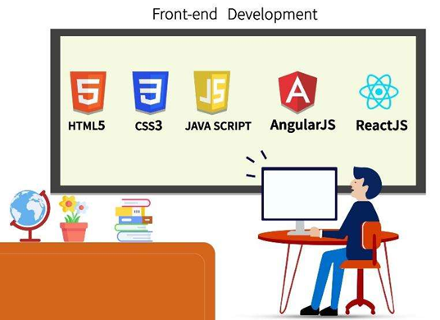

**Front-End Development:**

Clean, efficient code with HTML5, CSS3, JavaScript, React, and Angular.



**Back-End Development:**

Robust solutions using Node.js, Django, Ruby on Rails, and PHP.

* **Digital Marketing**

Boost your brand awareness with our digital marketing services. We provide a wide range of digital marketing services:

I. **SEO**: Improve search rankings and visibility.  
II. **PPC Advertising**: Targeted campaigns on Google and social media.  
III. **Social Media Marketing**: Engage users on platforms like Facebook, Instagram, Twitter, and LinkedIn.  
IV. **Content Marketing**: Create high-quality content to attract and retain your audience.  
V. **Email Marketing**: Personalized campaigns to nurture leads.  
VI. **CRO**: Optimize website elements to increase conversions.

* **SEO**

Website is a sales tool for your business. Ranking high on Google builds your reputation in the customer’s mind.

* **Explore The Services We Offer for You**

We provide a wide range of solutions from building your identity to showcasing your business to your audience. We offer services including:

* Website Development
* Mobile Application
* Digital Marketing
  + Social Media Marketing (any platform)
  + Social Media Management
  + Search Engine Optimization (SEO)
  + Search Engine Marketing (SEM)
  + Google AdWords

**CHAPTER 3:**

**Types of Major Equipments/raw materials/ instruments/machines/ hardware/software used in industry with their specifications, approximate cost, specific use and routine maintenance done**



**Computer Systems:**

Count: 40

Configuration:

* Processor: Intel i5
* Memory: 4GB
* HDD: 240GB
* OS:
  + Ubuntu
  + Windows 10

**Softwares:**

Editors:

* VS Code
* Sublime Text

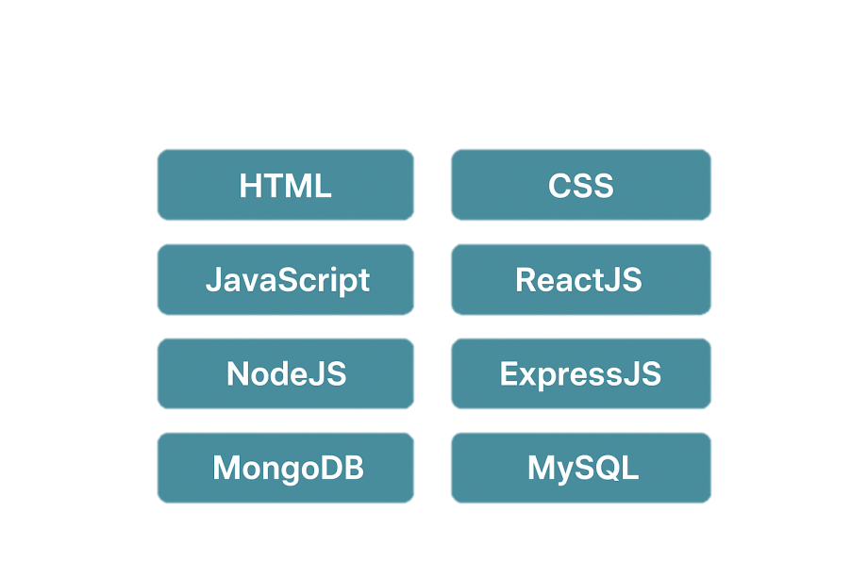**Server:**

* ExpressJS

**Technology listing**

* HTML
* CSS
* JavaScript
* ReactJS
* NodeJS
* MongoDB

**CHAPTER 4:**

**Development Process And Manufacturing techniques and methodologies and Software development procedures**



**Software Development Process**

* **Communication**
* This is the first step where the user initiates the request for a desired software product. He contacts the service provider and tries to negotiate the terms.
* He submits his request to the service-providing organization in written format.
* **Planning**
* The team comes up with a rough plan of the software process. At this step, the team analyzes if software can be made to fulfil all requirements of the user and if there is any possibility of the software being no more useful.
* It is found out if the project is financially, practically, and technologically feasible for the organization to take up. There are many algorithms available which help developers conclude the feasibility of a software project.
* **Designing**
* Next step is to bring down the whole knowledge of requirements and analysis on the desk and design the software product. The inputs from users and information gathered in the requirement-gathering phase are the inputs of this step.
* The output of this step comes in the form of two designs: logical design and physical design. Engineers produce metadata and data dictionaries, logical diagrams, dataflow diagrams, and in some cases pseudo codes.
* **Coding**
* This step is also known as the programming phase. The implementation of the software design starts in terms of writing program code in the suitable programming language and developing error-free executable programs efficiently.

**CHAPTER 5:**



**Testing of Hardware/Software Along with Testing of System Configuration, Network and Necessary Tools for Software Development.**

**TESTING:**

An estimate says that 50% of the whole software development process should be tested. Errors may ruin the software from a critical level to its own removal. Software testing is done while coding by the developers, and thorough testing is conducted by testing experts at various levels of code such as module testing, program testing, product testing, in-house testing, and testing the product at the user’s end. Early discovery of errors and their remedy is the key to reliable software.

TOOLS USED FOR SOFTWARE TESTING

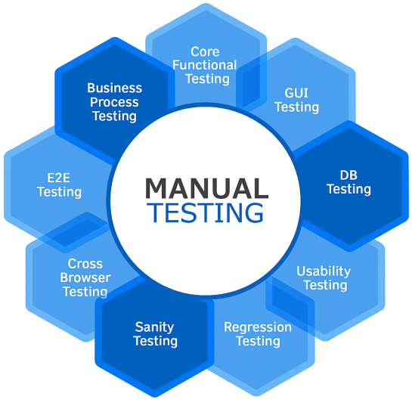**MANUAL TESTING:**

Manual testing is the process of using the functions and features of an application as an end user would in order to verify the software is working as required. With manual testing, a tester manually conducts tests on the software by following a set of pre-defined test cases. In order to successfully conduct manual tests, you first need to understand the requirements of the software. This is a crucial part of manual testing as the main goal is to make sure the software is bug free.

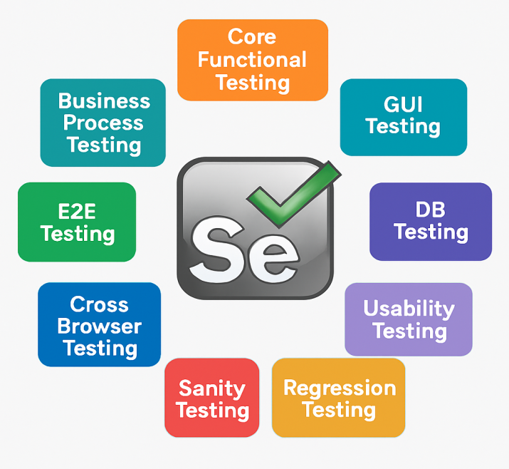

**SELENIUM:**

Selenium is a portable framework for testing web applications. Selenium provides a playback (formerly also recording) tool for authoring functional tests without the need to learn a test scripting language (Selenium IDE). It also provides a test domain-specific language to write tests in a number of popular programming languages, including C#, Groovy, Java, Perl, PHP, Python, Ruby and Scala. The tests can then run against most modern web browsers. Selenium deploys on Windows, Linux, and macOS platforms.

**CHAPTER 6:**



**Safety procedures followed and safety gears used by industry(Preventive Measures – Software Development Process)**

* Failure modes, including hardware, software, human and system are addressed in the design of the software.
* Sound software engineering practices and documentation are used in the development of the software.
* Software is designed for human machine interface, ease of maintenance and modification or enhancement.
* Software with safety-critical functionality must be thoroughly verified with objective analysis

**CHAPTER 7:**



**Particulars of Practical Experiences in Industry/Organization if any in Production/Assembly/Testing/Maintenance**

**TECHNOLOGIES USED DURING TRAINING**

At the site of our industry, there were expected numbers of computer systems available, each connected to main server sharing the network. Screen projector and display setup enhanced the learning experience.

Overall, front end, back-end and middle ware layers were learned during this period, letting us learn few programming languages

#### **WHAT WE HAVE LEARNED?**

* + HTML
  + CSS
  + JavaScript
  + ReactJS
  + NodeJS
  + MongoDB
  + ExpressJS

in purpose of learning to make interactive webpages.

## **HTML**

HTML stands for **Hyper-Text Markup Language**. It is used to design web pages using a markup language. HTML is the combination of **Hypertext** and **Markup language**.

Hypertext defines the link between web pages. A markup language is used to define the text document within the tag, which defines the structure of web pages.

This language is used to annotate (make notes for the computer) text so that a machine can understand it and manipulate text accordingly.

Most markup languages (e.g., HTML) are human-readable. The language uses **tags** to define what manipulation has to be done.

* **CSS**

**Cascading Style Sheets (CSS), referred as CSS, is a simple language intended to simplify the process of making web pages presentable.**

**CSS allows you to apply styles to web pages. More importantly, CSS enables you to do this independent of the HTML that makes up each web page. It describes how a web page should look: it prescribes colors, fonts, spacing, and much more.**

**In short, you can make your website look however you want.**

**CSS lets developers and designers define how it behaves, including how elements are positioned in the browser.**

**While HTML uses tags, CSS uses rulesets. CSS is easy to learn and understand, but it provides powerful control over the presentation of an HTML document.**

* **JavaScript**

******JavaScript (JS)** is a **high-level, lightweight, and interpreted programming language** that is primarily used to make web pages **interactive and dynamic**. It was developed by **Brendan Eich** in 1995 while working at Netscape. Today, JavaScript is one of the **core technologies of the web**, alongside **HTML** and **CSS**. JavaScript allows developers to **add behavior to web pages**, such as responding to user actions, validating forms, creating animations, and updating content dynamically without reloading the entire page. Modern JavaScript is not limited to the browser—it can also run on servers (with **Node.js**) and in mobile and desktop applications.

* **Python**

**Python** is a high-level, interpreted, and general-purpose programming language created by **Guido van Rossum** in 1991. It emphasizes **readability, simplicity, and ease of learning,** making it popular among beginners and professionals alike. Python supports multiple programming paradigms, including **procedural, object-oriented, and functional programming.** It comes with a **large standard library** and extensive **third-party packages,** which allow developers to build web applications, data analysis tools, AI models, automation scripts, and more. Python is **cross-platform**, meaning it runs on Windows, Linux, and macOS. Its dynamic typing, automatic memory management, and strong community support make it highly versatile and widely adopted in industry and academia.

* **Django**

**Django** is a free and open-source **Python-based web framework** designed for rapid development and clean, pragmatic design. It follows the **Model-View-Template (MVT)** architectural pattern, which separates data, business logic, and presentation for better maintainability. Django comes with built-in features like **ORM (Object-Relational Mapping), authentication, admin panel, and routing,** reducing the need for repetitive coding. It emphasizes **reusability of components, security,** and **scalability,** making it suitable for both small and large web applications. With Django Templates, developers can create **dynamic HTML pages** easily by combining backend data with frontend layouts. It also supports multiple databases like **SQLite, PostgreSQL, and MySQL**, and integrates seamlessly with modern frontend technologies if needed.

* **SQLite3**

**SQLite3** is a lightweight, open-source **relational database management system (RDBMS)** that comes bundled with Python and Django by default. Unlike other databases, it does not require a separate server process; instead, it stores the entire database in a single file on the disk. It uses **SQL (Structured Query Language)** for defining and manipulating data in the form of **tables, rows, and columns**. Because of its simplicity, zero-configuration, and low memory usage, SQLite is widely used for **small to medium-sized applications, prototyping, and testing**. In Django projects, SQLite3 is the default database, making it easy for beginners to start development quickly. It is **fast, reliable, and cross-platform,** though not as scalable as PostgreSQL or MySQL for very large applications.

**CHAPTER 8:**

**Detailed report of the tasks undertaken (during the training).**



**DigiVote: Digital Election Portal:-**

During my Internship at Passion Software Solutions, Jalgaon. We team of two members Snehal Sharma and Mokshada Patil were assigned the task to create a College Alumni.

The idea behind this project was to build a secure, transparent, and user-friendly platform where voters can cast their votes digitally while ensuring authenticity and fairness.

* Tech Stack Used
* Frontend: HTML, CSS, JavaScript
* Backend: Python,Django
* Database: SQLite
* Authentication: Role-based signup and login using Django authentication system
* Key Features
* Role-Based Authentication – Teacher and Student login ensures only authorized users can access their respective dashboards.
* Teacher Dashboard (Admin Role) – Manage events, assignments, notes, attendance, and courses; add or delete data easily.
* Student Dashboard – Register for events, download assignments/notes, view attendance, and participate in campus activities.
* Simple & Secure Data Handling – Teachers can delete old records and add new ones; students can only view/download, ensuring data integrity.
* sProtected Routes – Only logged-in teachers or students can access their respective dashboards, preventing unauthorized access.
* Real-Time Updates – Teacher dashboard reflects latest data immediately, so students always see current information.
* Scalable & Future-Ready – System structure allows adding features like multi-teacher management or edit/update option in the future.
* **Outputs of Project Created**
* **Landing Page**

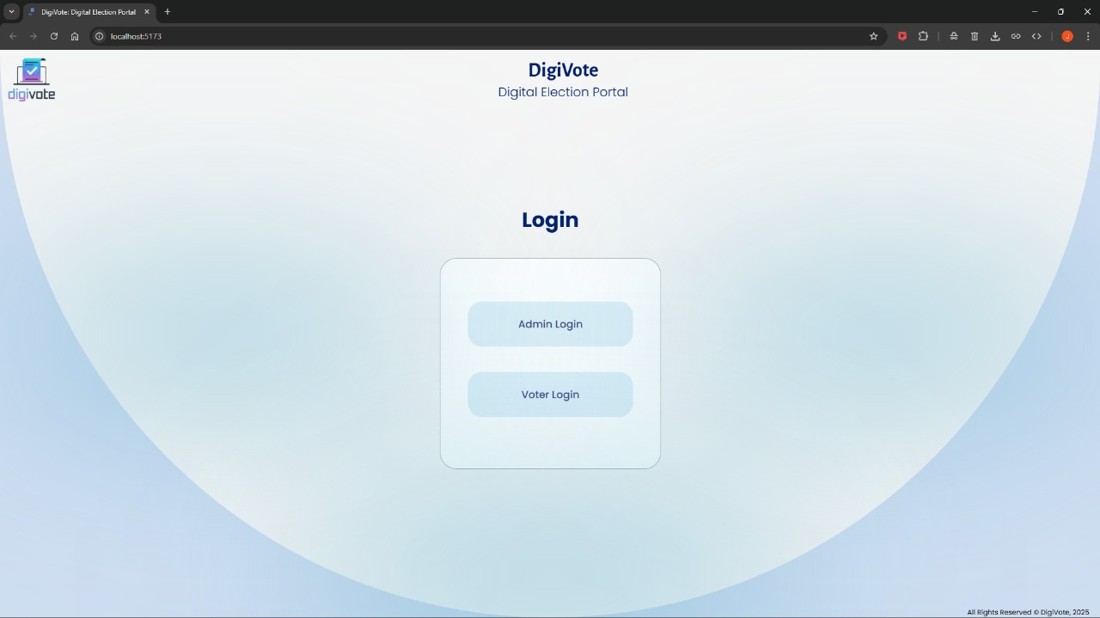

* **Admin Side**
  + **Admin Login**

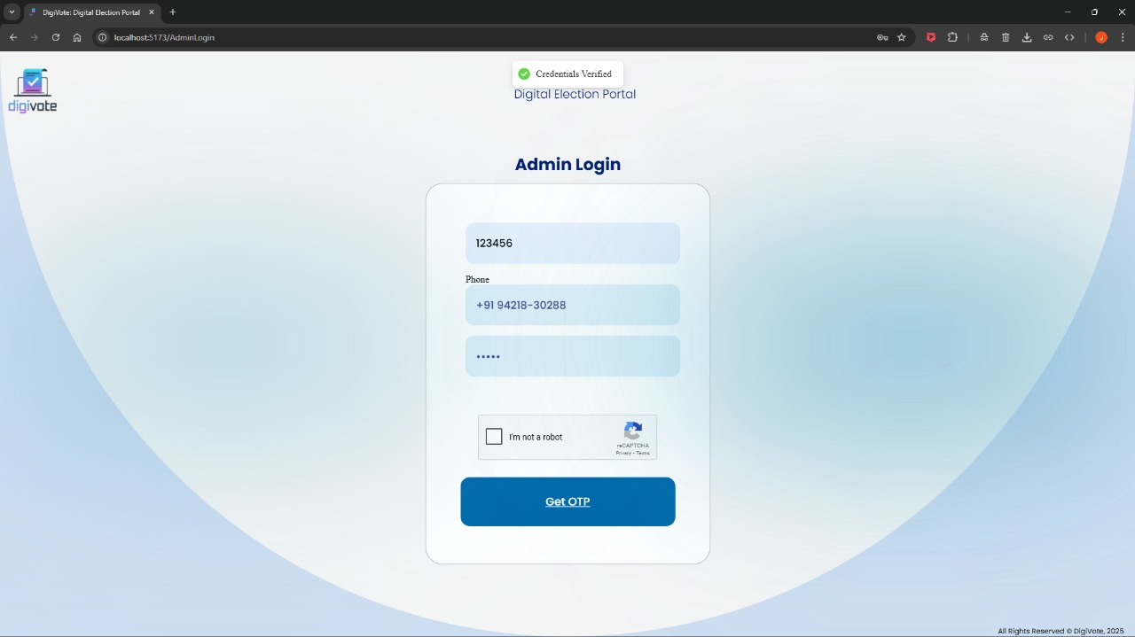

After Clicking Get OTP Admin will be Redirected to next Page i.e. Verify OTP

* + **Verify OTP**

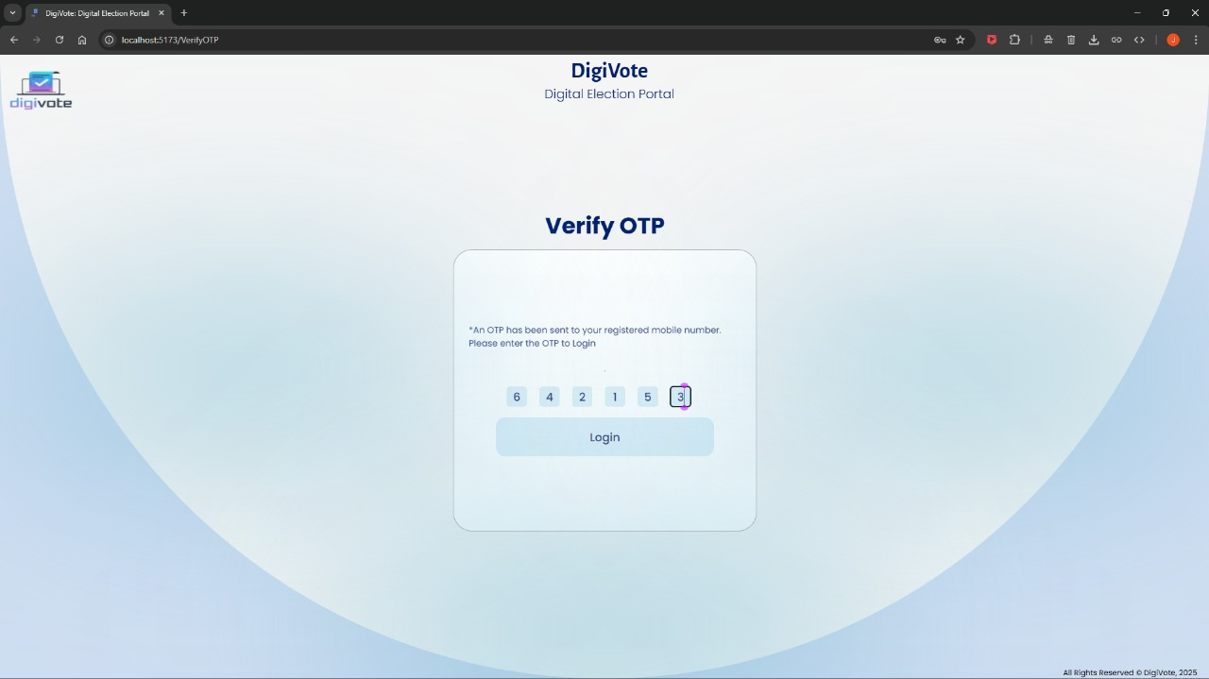

After Clicking Login Admin will be Redirected to Admin Dashboard

* + **Admin Dashboard**

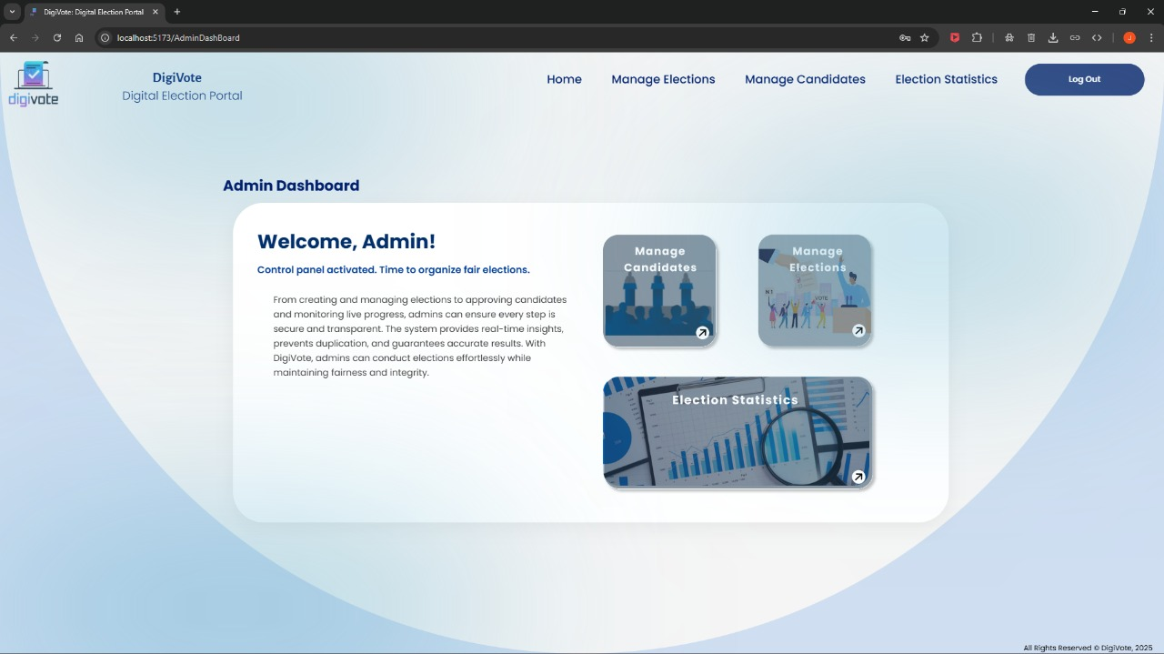

There are 3 Menus in Admin Dashboard

1. Manage Candidates 2. Manage Elections 3. Election Statistics

And Logout Button to Logout i.e. End Session

* + - **Manage Candidates**

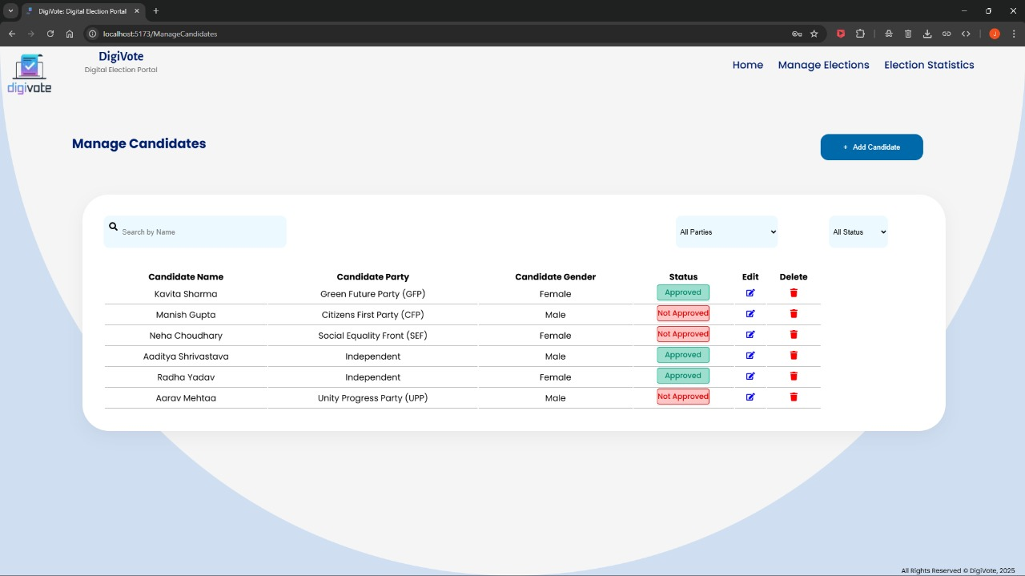

In Manage Candidates Admin Has Right to Approve or Not Approve Candidate only Approved candidate will be shown to Voter to Vote. Admin can also Edit or Delete the Candidates and Has a Filter upon Search, Party wise & Status wise. Admin Also has Button to Add Candidate when Admin Clicks on it then Admin will be Redirected to Add Candidate Page.

* + - * **Add Candidate**

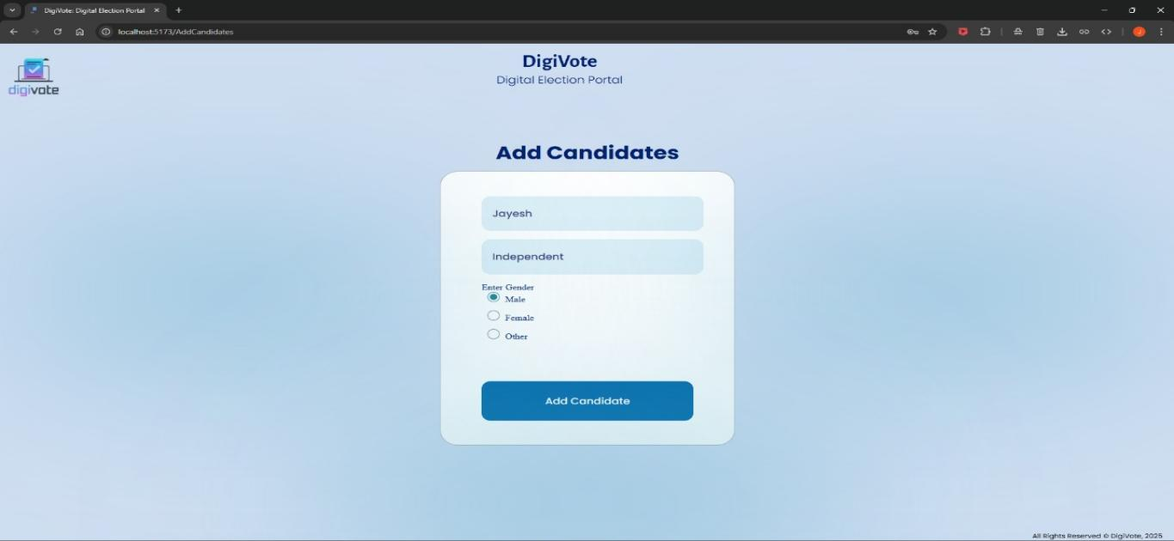

In Add Candidates Page Admin can Add Candidate Upon Details given by Candidate and Redirected to Manage Candidates page

* + - **Manage Elections**

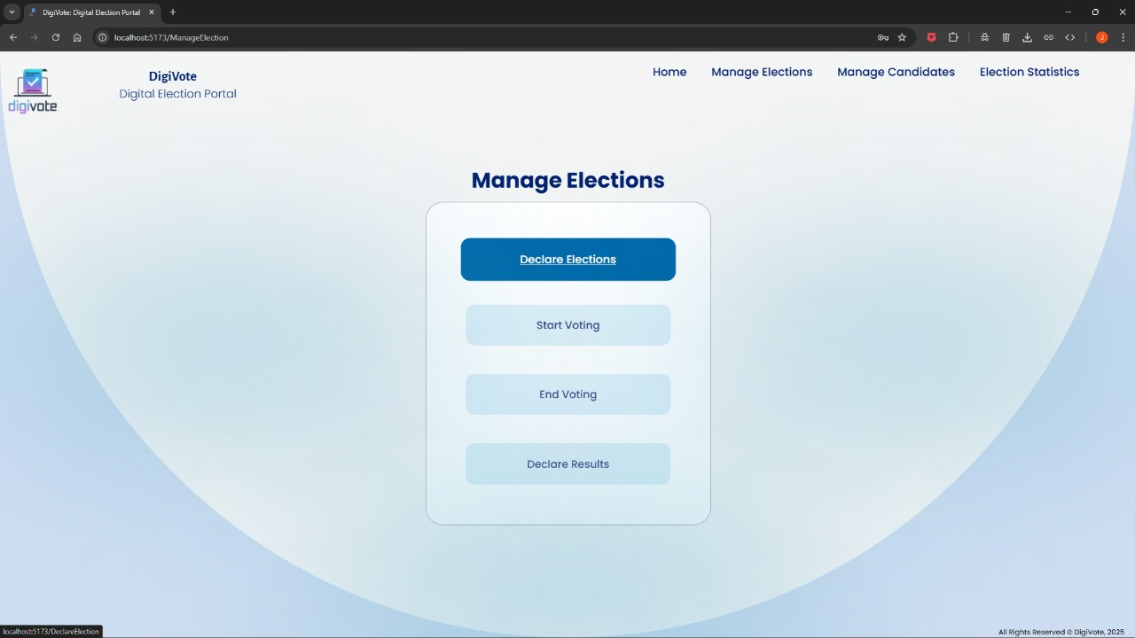

In Manage Elections Page Admin can Start Voting, End Voting, Declare Results & Declare Elections. After Clicking Declare Elections the Admin Will be Redirected to Declare Elections Page.

* + - * **Declare Elections Page**

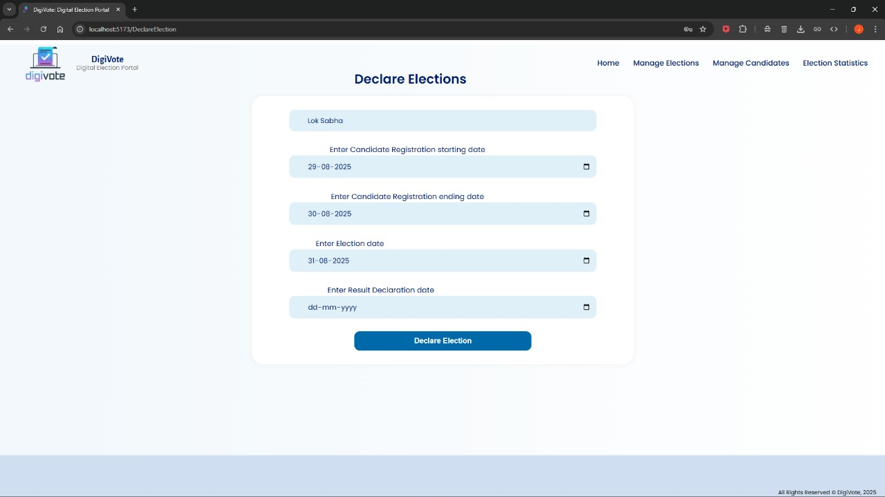

In Declare Elections Page Admin Has To Fill Election Name, Candidate Registration Starting And Ending Date, Voting Date & Result Declaration Date. After Clicking Declare Election Admin will be Redirected to Admin Dashboard.

* + - **Election Statistics**

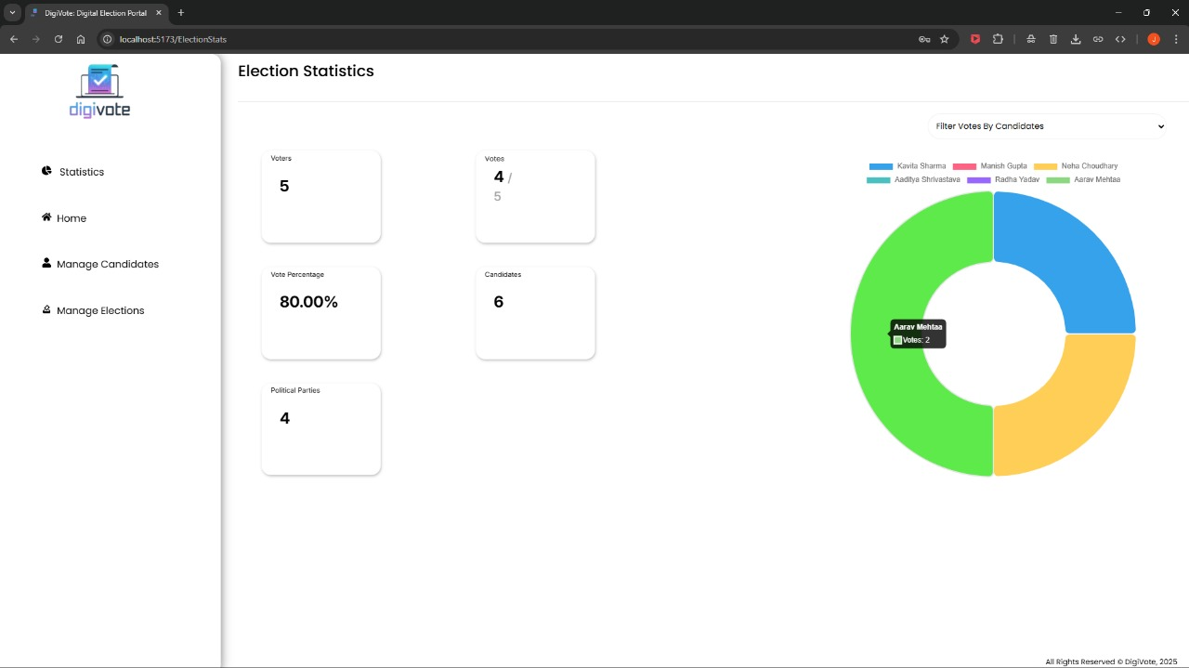

In Election Statistics Page Admin Can see number of Voters, Votes Casted, Percentage of Votes Casted, Number of Political Parties, Number of Candidates, Chart Featuring Votes Based on Candidate and Filters Based on Political Party and Candidate.

* **Voter Side**
  + **Voter Login**

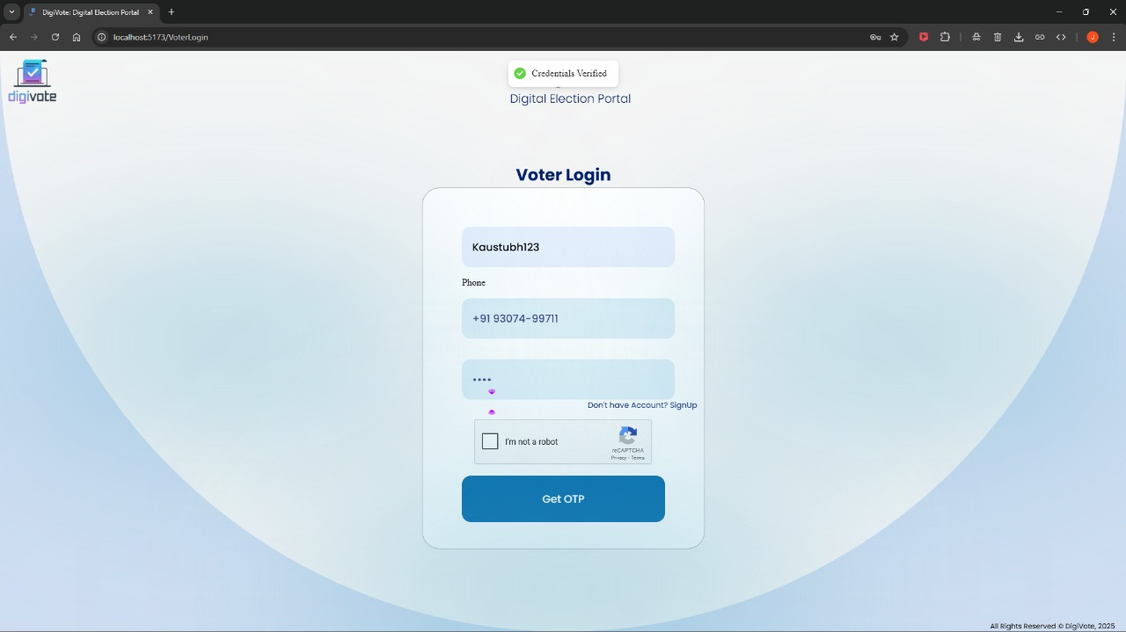

After Clicking Get OTP Voter will be Redirected to next Page i.e. Verify OTP

* + Verify OTP

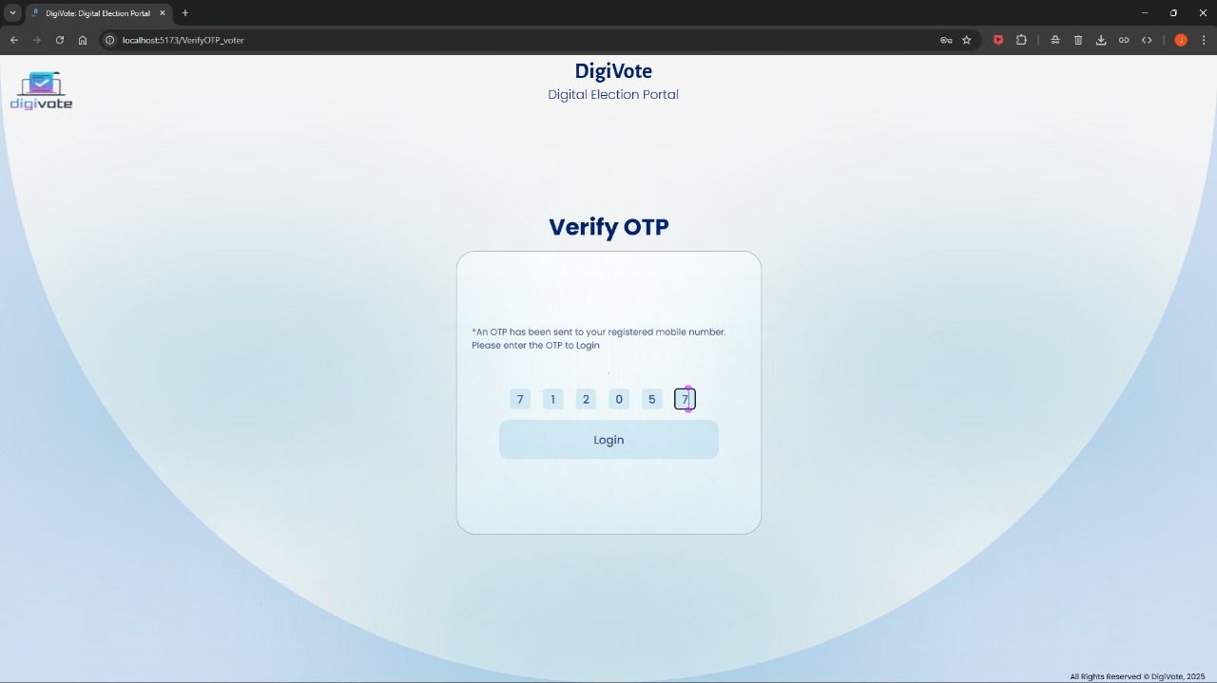

After Clicking Login Admin will be Redirected to Voter Dashboard

* + **Voter Dashboard**

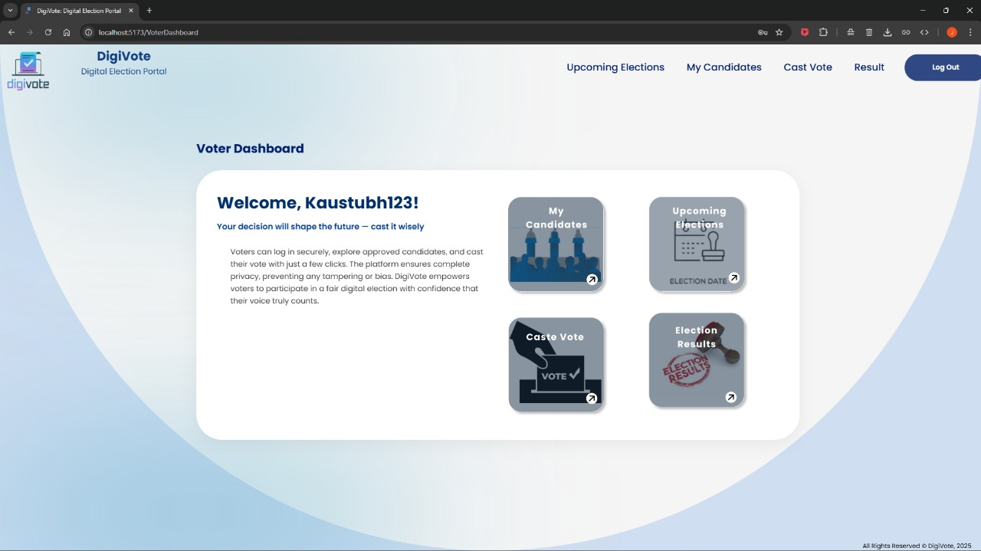

There are 4 Menus in Voter Dashboard

1. My Candidates 2. Upcoming Elections 3. Cast Vote 4. Election Results

And Logout Button to Logout i.e. End Session

* + - **My Candidates**

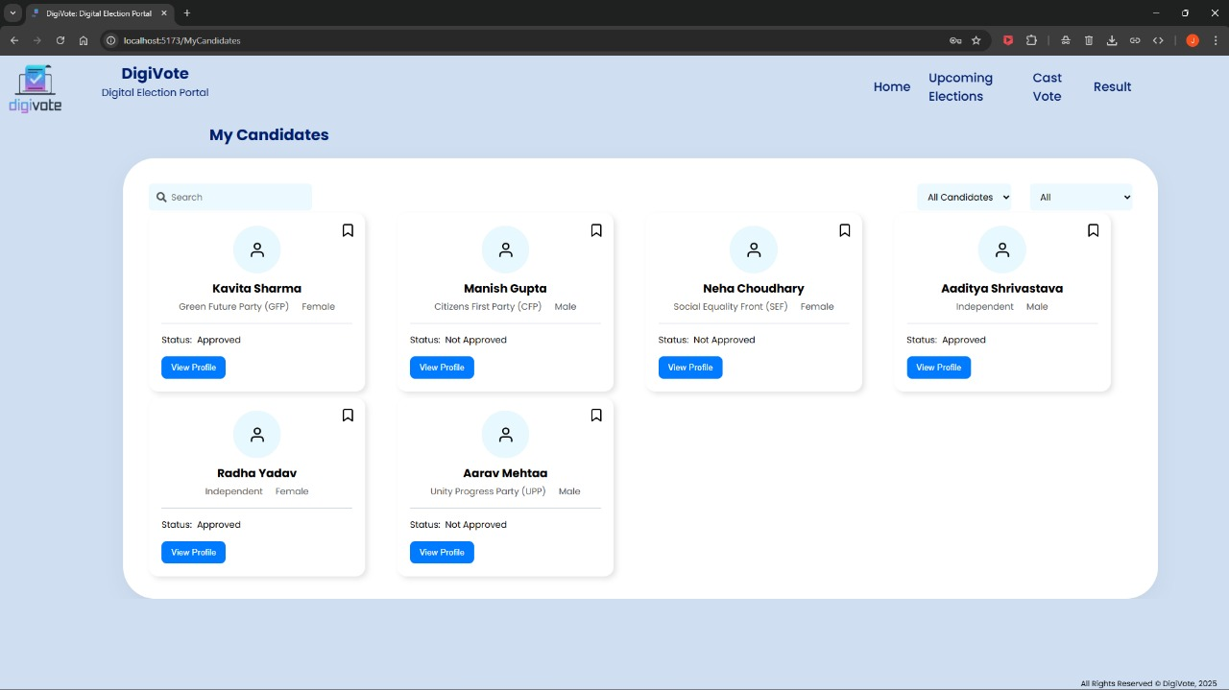

In My Candidates Page Voter Has Right to Bookmark Candidate Filter Candidates Based upon Approval & upon Party and When Voter click on View Profile Following Popup will be Shown

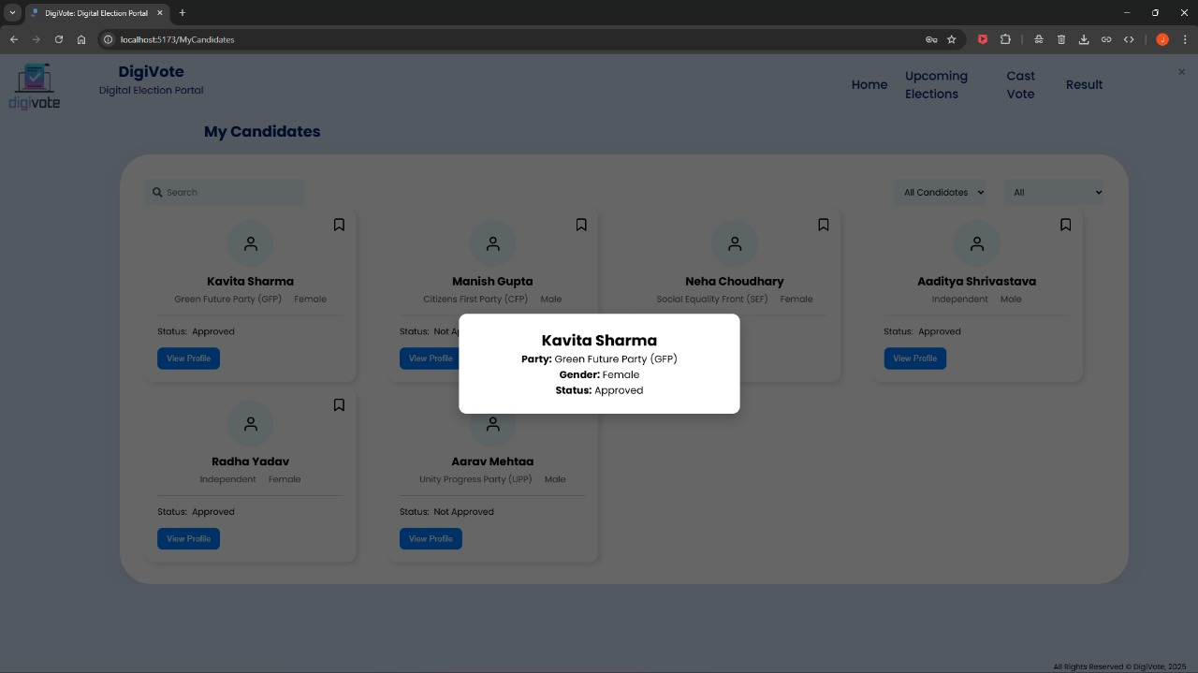

In Popup Voter will be Showed Name of Candidate, Party Name, Gender & Status of Candidate

* + - **Upcoming Elections**

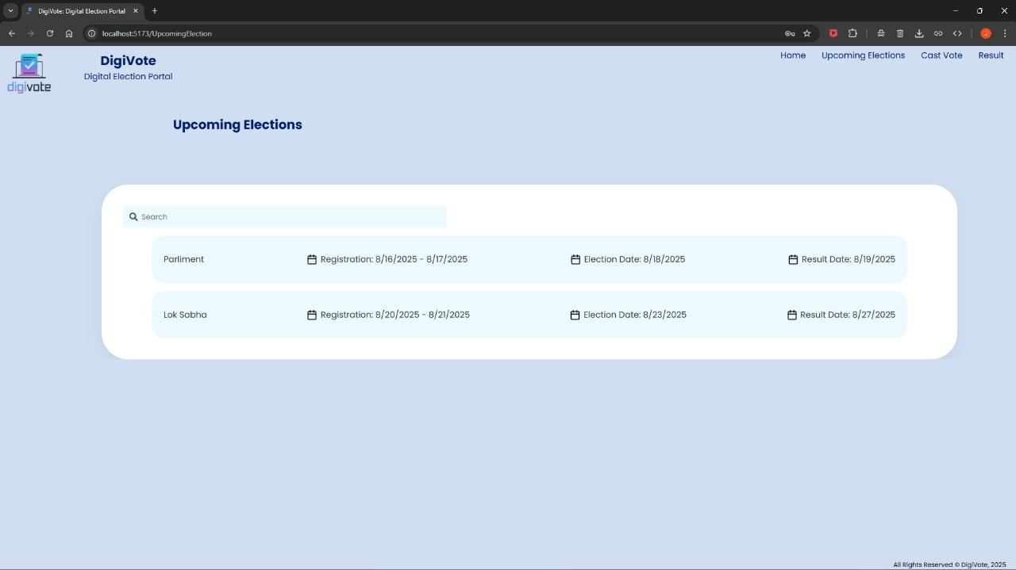

In Upcoming Elections Page Voter Can See Next Elections and can also see their Registration, Voting & Result Date

* + - **Cast Vote**

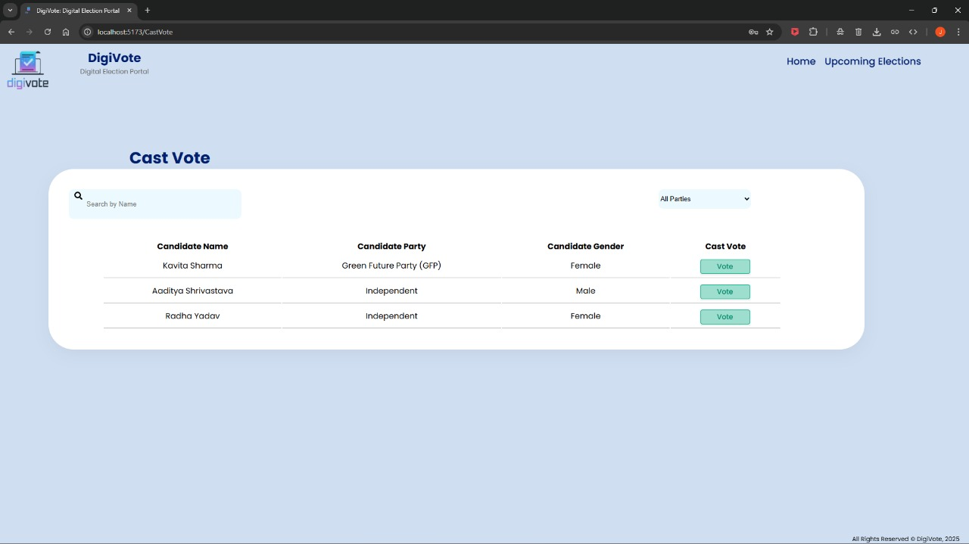

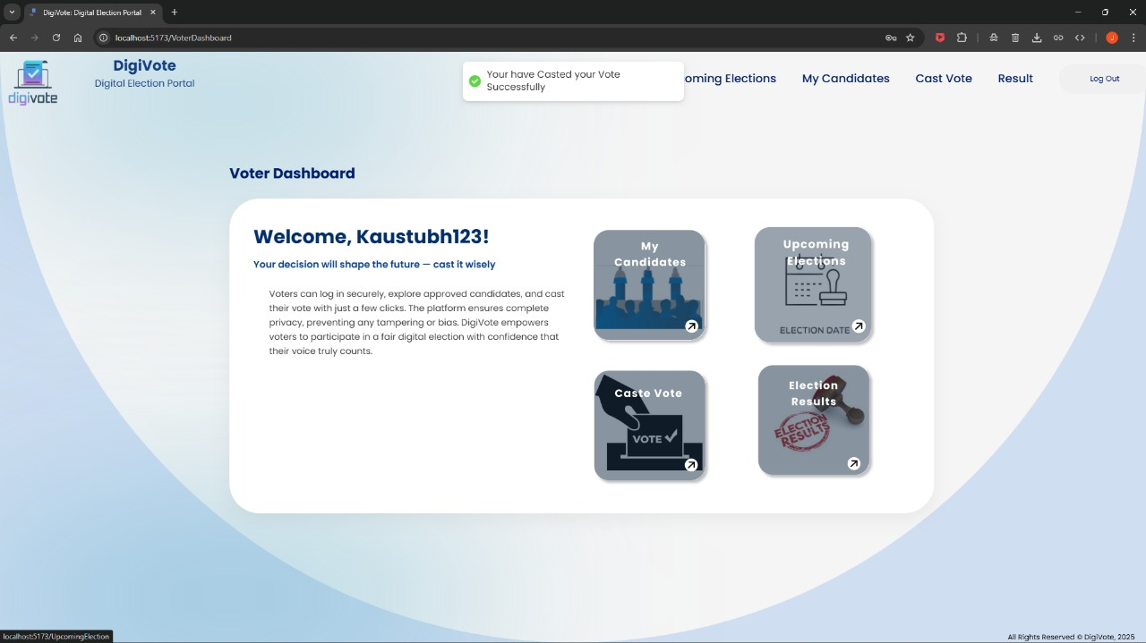In Cast Vote Page Voter can Cast Vote and can apply filter based upon Parties and after Voting Voter will be Redirected to Voter Dashboard. When Voter is Redirected on Dashboard following Alert will Appear on Voter Dashboard

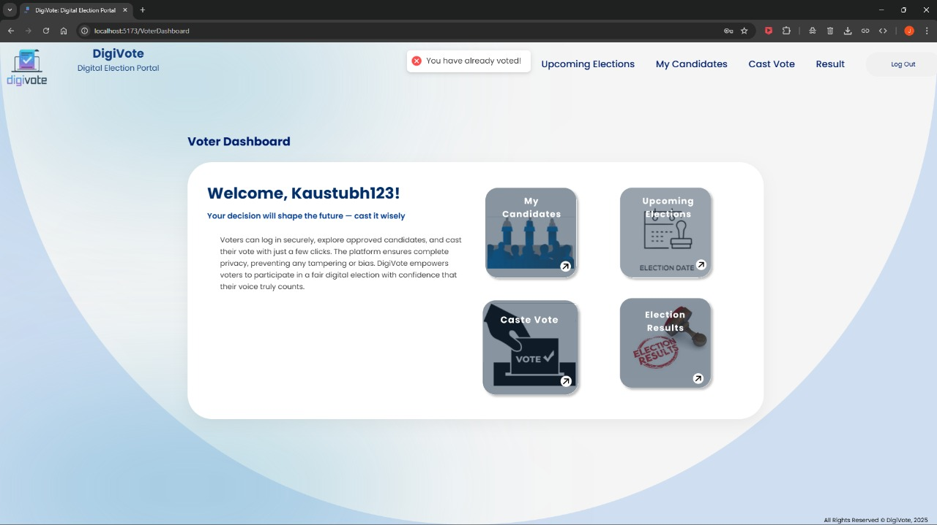

When Voter Tries to Cast Vote Again The Above Error will Appear.

* + - **Election Results**

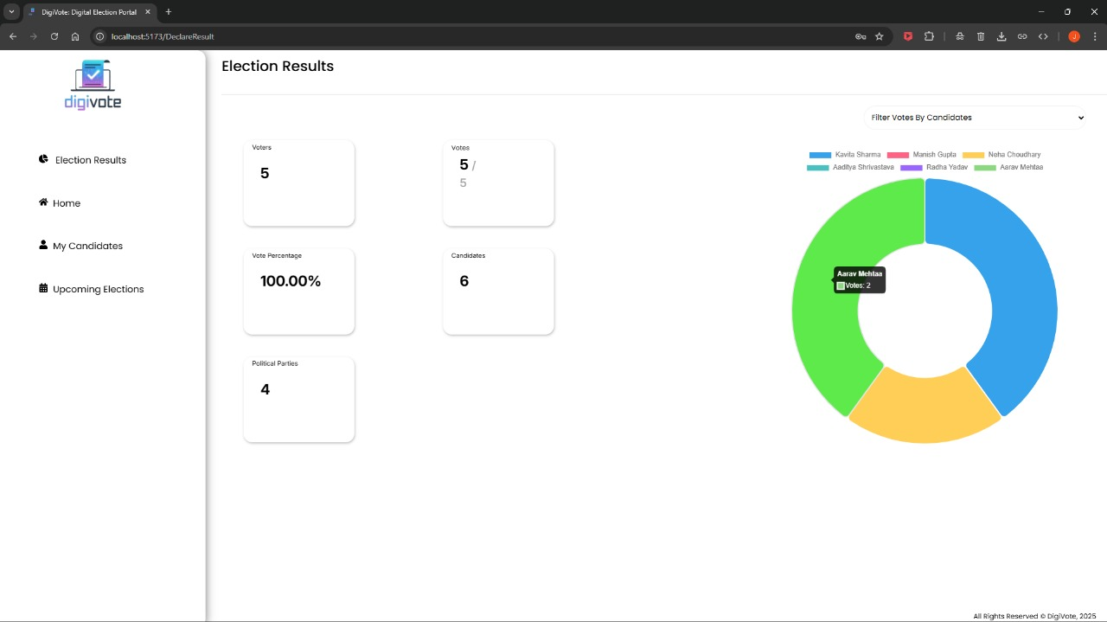

In Election Result Page Voter Can see number of Voters, Votes Casted, Percentage of Votes Casted, Number of Political Parties, Number of Candidates, Chart Featuring Votes Based on Candidate and Filters Based on Political Party and Candidate.

* **Database Structure (MongoDB)**

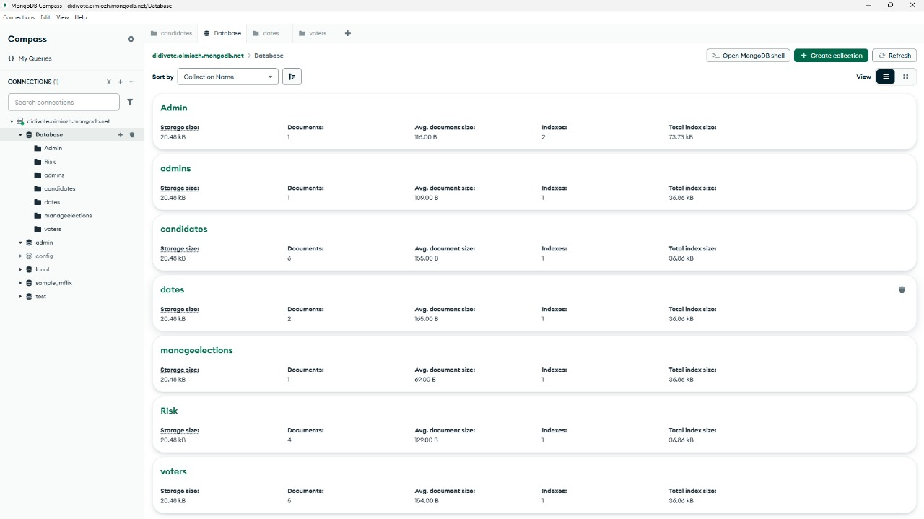

Above Image Shows The Structure of Database i.e. Collections, Storage Size, number of Documents, Avg. Document size, Indexes, Total Index Size

* **Candidate Collection**

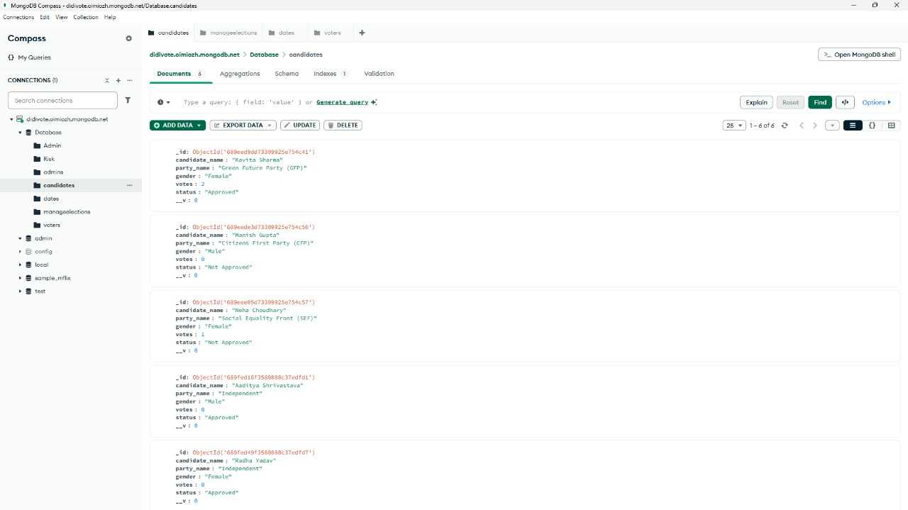

Above Image shows Candidate collection i.e. Structure of Each document and Values in it.

**CHAPTER 9:**

**Special/challenging experiences encountered during training.**



* Integrating different components of the full stack (front-end, back-end, and database) sometimes presented challenges that were difficult to address within the limited training period.
* The time allocated for project development was often limited, which sometimes restricted our ability to fully implement and test features or to explore all possible solutions in depth.
* The training focused on a specific set of technologies (e.g., React.js, Node.js, etc.) which, while essential, did not cover other popular or emerging technologies that could be relevant in different contexts.

Top of Form

**CHAPTER 10:**

**Conclusion**



Our internship on **Python and Django Web Development**, conducted at **Passion Software Solutions**, has been an enriching and transformative experience. Over the course of the project, we gained comprehensive knowledge and hands-on experience in developing dynamic web applications using Django and SQLite, including role-based dashboards for teachers and students, managing events, assignments, attendance, and notes. This project equipped us with the skills necessary to design secure, user-friendly, and real-world web applications

**CHAPTER 11:**

**References / sources of information**



Bottom of Form

* **Figma Design Link:-** [https://www.figma.com/design/gH4sBp6TQofvqB0E1r5UFH/ITR-Project?node- id=36-408&t=mxYO01C3p9WNt0rb-0](https://www.figma.com/design/gH4sBp6TQofvqB0E1r5UFH/ITR-Project?node-id=36-408&t=mxYO01C3p9WNt0rb-0" \o "DigiVote: Digital Election Portal)
* **Github Repository Link:**- [https://github.com/Kaustubh1277/ITR](https://github.com/Kaustubh1277/ITR" \o "DigiVote:Digital Election Portal Repository)
* <https://code.visualstudio.com/>
* <https://react.dev/>
* <https://nodejs.org/en>
* <https://expressjs.com/>
* <https://www.mongodb.com/>
* <https://www.w3schools.com/html/>
* <https://www.geeksforgeeks.org/css/css-tutorial/>
* <https://developer.mozilla.org/en-US/docs/Web/JavaScript>